**Experiment No :** 17

**Experiment name :** Write a C program to find a digit (first, last, min, max) from an array

**Methodology :**

1. Initialize the array with elements.
2. Find the first and last digits by accessing the first and last elements of the array.
3. Find the minimum and maximum digits by iterating through the array.
4. Print the results.

**\Flow-Chart :**

int n ,i, min,max , arrays[100];

scanf("%d",&n);

**Code :**

yes

Mx=arr[i];

yes

no

no

yes

no

yes

no

I++

Arr[i]<mn?

Print : mx , mn ;

I<n?

Mx=arr[i];

Arr[i]>mx?

I<n?

Mx = arr[i];

Mn = arr[i];

I++

I++

scanf("%d" , &arrays[i]);

#include<stdio.h>

int main(){

int n ,i, min,max , arrays[100];

printf("Enter Number of array : ");

scanf("%d",&n);

printf("Enter elements in array :\n");

for(i=0 ; i<n ; i++ ){

scanf("%d" , &arrays[i]);

}

//fint minimum array

min = max = arrays[0];

for(i=1 ; i<n ; i++){

if(min>arrays[i]){

min = arrays[i] ;

}

else{

if(max<arrays[i]);

max= arrays[i];

}

}

printf("Minumum of array is %d",min);

printf("\tMaximum of array is %d",max);

return 0;

}

**Output:**

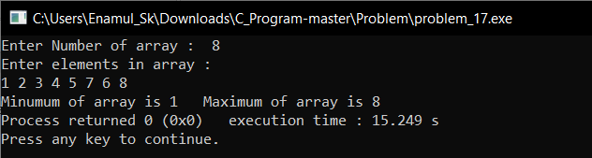

**Result discussion :**

findFirstDigit: This function returns the first element of the array.

findLastDigit: This function returns the last element of the array.

findMinDigit: This function iterates through the array and finds the minimum element.

findMaxDigit: This function iterates through the array and finds the maximum element.